Year 2
Curriculum Booklet

Introduction

This booklet is a guide to your daughter’s current academic year, giving you an overview of the content of our curriculum at St. Mary’s. Our curriculum has been devised to interest and engage your daughter, with the intention to help realise her potential. As with all the best teaching, it may be liable to changes as we respond to the questions, interests and particular needs of the girls, but it will give you a broad idea of the year ahead.

If you have any questions please speak with your daughter's class teacher or Mrs Zoe Wentworth, Assistant Director of Lower School (Academic).

Year 2 Yearly Overview for English
(Your daughter will be assessed against the following criteria)
Reading | Writing
- Reads accurately by blending the sounds in words that contain the graphemes taught so far especially recognising alternative sounds for graphemes.  - Reads accurately words of two or more syllables that contain the same graphemes as above.  - Reads most words at an instructional level 93-95 per cent quickly and accurately without overt sounding and blending, when they have been frequently encountered.  - Reads aloud books closely matched to their improving phonic knowledge, sounding out unfamiliar words accurately, automatically and without undue hesitation.  - Re-reads these books to build fluency and confidence in word reading.  Develops pleasure in reading, motivation to read, vocabulary & understanding by:  - Listening to, discussing and expressing views about a wide range of contemporary and classic poetry, stories and non-fiction at a level beyond that at which they can read independently.  - Discussing the sequence of events in books and how items of information are related.  - Becoming increasingly familiar with a wider range of stories, fairy stories and traditional tales.  - Retelling a range of stories, fairy stories and traditional tales, and being introduced to non-fiction books that are structured in different ways.  - Understand both the books they can already read accurately and fluently and those that they listen to by.  - Checking that the text makes sense to them as they read and correcting inaccurate reading.  - Answering questions and predicting what might happen on the basis of what has been read so far.  - Participates in discussions about books, poems and other works that are read to them and those they can read for themselves, taking turns and listening to what others say. | - Writes capital letters and digits of the correct size, orientation and relationship to one another and to lower case letter.  - Develops positive attitudes towards, and stamina for, writing, by writing for different purposes.  - Considers what is going to be written before beginning by encapsulating what they want to say, sentence by sentence.  - Makes simple additions, revisions and corrections to writing by proof-reading to check for errors in spelling, grammar and punctuation.  - Segmenting spoken words into phonemes and representing these by graphemes, spelling many correctly.  - Learning new ways of spelling phonemes for which one or more spellings are already known; and learn some words with each spelling, including a few common homophones.  - Uses the suffixes –er, –est in adjectives and –ly to turn adjectives into adverbs  - Constructs subordination (using when, if, that, because) and co-ordination (using or, and, but).  - Uses the correct choice and consistent use of present tense and past tense.  - Uses capital letters, full stops, question marks and exclamation marks to demarcate sentences.  - Use commas to separate items in a list.
Year 2 Yearly Overview for Mathematics
(Your daughter will be assessed against the following criteria)

Number and place value  Counts in steps of two, three, and five from 0, and in tens from any number, forward and backward  Compares and orders numbers from 0 up to 100  Uses < > and = signs correctly  Uses place value and number facts to solve problems  Addition and subtraction  Solves problems with addition and subtraction by:  1. using concrete objects and pictorial representations, including those involving numbers, quantities and measures; and  2. applying an increasing knowledge of mental and written methods.  Recalls and uses addition and subtraction facts to 20 and 100:  1. fluently up to 20.  Multiplication and division  Recalls and uses multiplication and division facts for the two, five and 10 multiplication tables, including recognising odd and even numbers  Solves problems involving multiplication and division, using materials, arrays, repeated addition, mental methods, and multiplication and division facts, including problems in contexts  Fractions (including decimals)  Recognises, finds, names and writes fractions 1/3, 1/4, 2/4, and 3/4 of a length, shape, set of objects or quantity | Measurement  Solves simple problems in a practical context involving addition and subtraction of money of the same unit including giving change  Geometry: properties of shape  Compares and sorts common 2-D and 3-D shapes and everyday objects  Geometry: position and direction  Uses mathematical vocabulary to describe position, direction and  movement including movement in a straight line, and distinguishes between rotation as a turn and in terms of right angles for quarter, half and three-quarter turns (clockwise and anti-clockwise)  Statistics  Asks and answers questions about totalling and comparing categorical data
Year 2 Yearly Overview for Science
Topic / Area of study | Description | The skills the girls will develop through this topic
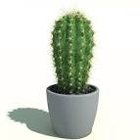  Plants | To explore and investigate plants throughout the different season and in different habitats. | Identify, classify and describe the basic structure of a plant.  To observe and describe growth and the conditions needed for growth.  To look suitability of environments.
Animals, including humans  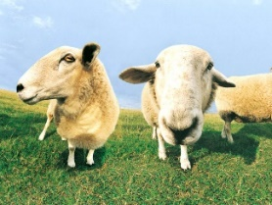  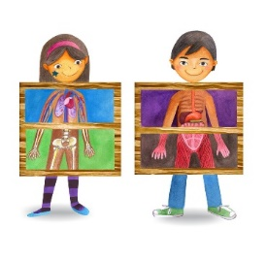 | We will learn to identify and name a variety of common animals that can be classified as carnivores, herbivores and omnivores.  We will study the characteristics of mammals including humans and notice that this class of animal have offspring who grow into adults.  Our study of the human body will see the girls labelling different parts of the body and saying which part of the body is associated with each sense. We will look at the functions of the main organs. Exercise and healthy eating will also feature as part of this area of learning. | Identify, classify and observe.  Look at growth, basic needs, exercise, food and hygiene.  Identify and name a variety of common animals that are carnivores, herbivores and omnivores.  Identify name, draw and label the basic parts of the human body and say which part of the body is associated with each sense.  Notice that animals, including humans, have offspring which grow into adults.  Investigate and describe the basic needs of animals, including humans, for survival (water, food and air).  Describe the importance for humans of exercise, eating the right amounts of different types of food and hygiene.
Everyday materials and their properties  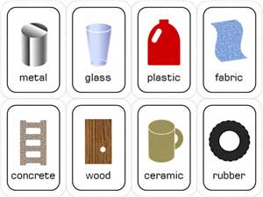  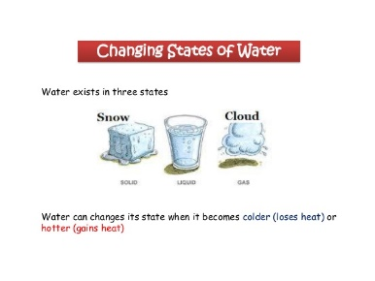 | We will identify and name a variety of everyday materials, including wood, plastic, glass, metal, water and rock and describe their simple physical properties such as transparency, strength, flexibility, texture and resistance to water.  We find out how the shapes of solid objects made from some materials, can be changed by squashing, bending, twisting and stretching. This topic will develop the ability to raise questions about working scientifically with the knowledge and skills that it brings.  The changing state of water will be explored through controlled experiments as we discover that some materials can change through heating and cooling.  We will identify and compare the suitability of a variety of everyday materials, including wood, metal, plastic, glass, brick/rock, and paper/cardboard for particular uses. | Identify and name a variety of everyday materials, including wood, plastic, glass, metal, water and rock.  Identify, name, describe, classify and compare properties and changes.  Look at the practical uses of everyday materials.  Observe closely, using simple equipment.  Perform simple tests.  Identify and classify.  Use observations and ideas to suggest answers to questions.  Gather and record data to help in answering questions.
Living things and their habitats  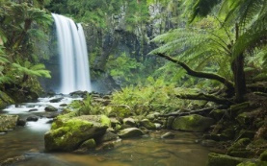  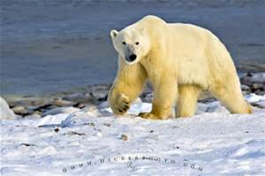 | We will become explorers of different habitats from around the world. We will learn how animals eat, live and survive in relation to the habitats in which they live and explore the idea of food chains.  We will travel through habitats including the oceans, polar regions, rainforest, desert and urban. Here we will discover how both animals and plants have adapted to living in these different habitats. We will make comparisons between contrasting eco-systems and discuss questions like: How do these animals survive in such harsh environments? Individual research projects will allow children to follow their own interests regarding these amazing animals of the world. | Identify and name a variety of plants and animals in their habitats, including micro-habitats.  Identify, classify and ask simple questions.  Describe how animals obtain their food from plants and other animals, using the idea of a simple food chain, and identify and name different sources of food.  Identify and name a variety of plants and animals in their habitats, including micro-habitats.
Year 2 - History
Topic / Area of study | Description | The skills the girls will develop through this topic
Famous People from the Past  (Including Mary Anning)  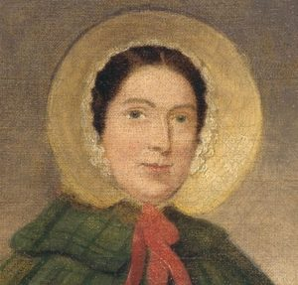 | In the Autumn term, we will encourage the girls to develop an awareness of the past by studying the lives of significant people who have contributed to national and international achievements.  A range of historical sources will be used to find information about the past such as online databases, encyclopaedias, artefacts and library books. | Ask questions such as: What was it like for people? What happened? How long ago?  Use artefacts, pictures, stories, online sources, and databases to find out about the past.  Describe significant people from the past.  The ability to think, reflect, debate, discuss and evaluate the past, formulating, and refining questions and lines of enquiry.  Explore historical events from the past and consider why they have been remembered.
The Great Fire of London  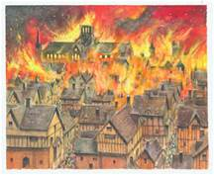  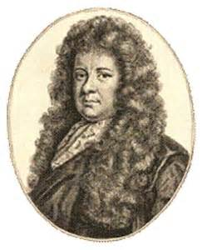 | We will study the Great Fire of London, we will learn how this significant event from the past happened, how it spread and what was done to stop it.  Comparisons between life then with life now in terms of having a Fire Brigade and safer houses will be discussed and explored in detail. Why are our cities safer from outbreaks of fire now?  We will understand the role Samuel Pepys played in this significant event from the past.  A developing understanding of chronology will be embedded by placing events on a timeline and using historical language to indicate the passing of time. | Place events and artefacts in order on a timeline.  Label timelines with words or phrases such as: past, present, older and newer.  Describe historical events.  Show an understanding of the concept of nation and a nation’s history.  Describe significant people from the past and understand how historical events are recorded in different forms of communication.
Local History.  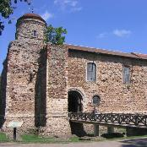 | We will consider significant historical events, places and people in their local environment and participate in storytelling, drama and hands-on-activities which will spark imaginations and develop an understanding of real-life history.  This historical study aims to develop an understanding of where people and events fit within a chronological framework and identify similarities and differences between ways of life in different periods. | Use dates where appropriate.  Show an understanding of concepts such as civilisation and monarchy.  Recognise that there are reasons why people in the past acted as they did.

Year 2 - Geography
Topic / Area of study | Description | The skills the girls will develop through this topic
Local area – London Road / Colchester  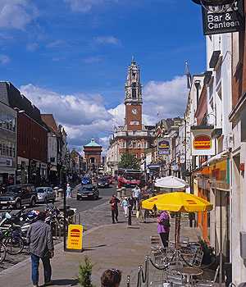 | During this study the girls will explore their immediate locality. They will use simple fieldwork and observational skills to study the geography of the street outside school. Including key human and physical features.  Using aerial images and maps of Colchester the girls will recognise landmarks and basic physical features such as parks, shops, residential areas and key services such as the fire station and hospital. | Use basic geographical vocabulary to refer to and describe key physical and human features of locations. Key human feature including: city, town, village, factory, farm, house, office and shops.  Use simple compass directions.  Use aerial photographs.  Use fieldwork and observational skills.  Identify land use around the school.
United Kingdom  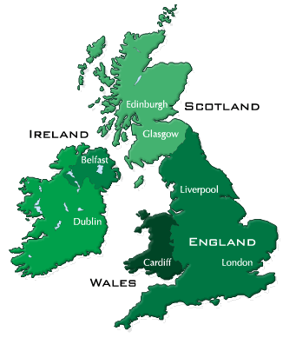 | We will investigate the different types of settlements, such as; city, town, village, coastal or rural area.  This topic will encourage geographical thinking, asking questions, such as; What is this place like? Who or what will I see in this place? | Ask and answer geographical questions.  Identify key features of a location in order to say what it is.  Use basic geographical vocabulary to refer to key physical features including: beach, cliff, coast, mountain, sea, ocean, river, vegetation, season and weather.
Continents and oceans of the world  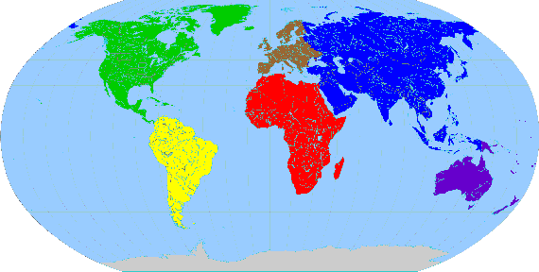 | We will learn about the oceans and continents of the world and understand how the world is constantly changing.  Weather is an interesting area of learning within this topic as we identify weather patterns and consider the location of hot and cold areas in relation to the Equator.  Through a case study in the developing world, we will compare similarities and differences. | Use world maps, atlases, and globes to identify the United Kingdom and its countries, as well as the countries, continents and oceans studied.  Name and locate the world’s continents and oceans.  Identify seasonal and daily weather patterns in the United Kingdom and the location of hot and cold areas of the world in relation to the Equator and the North and South Poles.  Understand geographical similarities and differences through studying the human and physical geography of a small area of the United Kingdom and of a contrasting non-European country.

Year 2 – Additional Subjects
RE
Topics to be covered:
- Special Times / Places / People
- Festivals & Celebrations
- Easter / Chinese New Year

PSCHEE/Philosophy
Topics to be covered:
- Feelings & Emotions – Worry & Anger.
- Our World – Living and Working in Our World Keeping/Staying Healthy – Healthy Eating, Brushing Teeth.
- Relationships – Bullying, Body Language.
- Special Module – Is it safe to eat or drink?
- Fire Safety – Petty Arson.
- Being Responsible – Practise Makes Perfect.
- Helping Someone in Need.
- Computer Safety – Image Sharing, Computer Safety Documentary.
- Keeping/ Staying Safe – Tying Shoelaces.

Computer Science
Topics to be covered:
- e-Safety
- Presentations and Typing
- Digital Books (Storyland)
- Coding 2a
- Different sorts
- of inputs
- Internet and Word-Processing Skills Coding 2b
- Buttons & Instructions

Languages
The girls will refine their base knowledge of French speaking and listening, increasing in confidence and fluency, continually improving their pronunciation. Amongst the topics they will be studying will be days and months, classroom objects, body parts, pets, family members, fruits, drinks and snacks. They will also work to develop their conversational skills. The girls will explore the differences between the cultural practices in the UK and French speaking countries.
Design and Technology
The girls will complete a STEM Lego project applying problem solving, critical thinking and spatial reasoning through hands-on building and design. They will work as a team to experiment with various solutions developing logical thinking. They will then make and evaluate their product.
Art and Design
Using the Art strands of drawing, painting, collage and textiles. The girls will use their experience and ideas as inspiration for artwork. They will explore a variety of techniques and learn from a range of artists and designers.
Music
- To develop performance skills accurately following the melody
- To be able to clap rhythmic patterns
- To use symbols to represent a composition and use them to help with a performance.
- To be able to recognise changes in timbre, dynamics and pitch

PE
- Uphold the spirit of fair play and respect in all competitive situations
- To participate in team games, developing simple tactics for attacking and defending
- To develop rolling, hitting, running, jumping, catching and kicking skills in combination
- To move with some control and awareness of space
- To develop greater agility, balance and co-ordination
- To be able to swim unaided

Forest School
Your daughter will have opportunities to develop her skills and knowledge in the following areas: Tool use, Ropes and Knots, Fires, Dens and Shelters, Tree climbing and Flora and Fauna. Personal, Social and Emotional Development is a constant feature throughout all of the sessions as the girls experience supported risk taking, physical challenges, working as part of a group, problem solving, choice, opportunities for reflection, solitude and discussion of feelings and emotions to promote self-awareness, social awareness and positive mental health.

French | Translation (English) | French | Translation (English) | French | Translation (English) | French | Translation (English)
Lundi  Mardi  Mercredi  Jeudi  Vendredi  Samedi  Dimanche  Bonjour  Salut  Bonsoir  Bonne nuit  Au revoir  Monsieur  Madame  Mlle  Ҫa va?  Ҫa va  Comme ҫi, comme ҫa  Pas bien  Ҫa ne va pas  Ҫa va mal  Je m’appelle…et toi?  Nombre:  Un  Deux  Trois  Quatre  Cinq  Six  Sept  Huit  Neuf  Dix  Onze  Douze  Treize  Quatorze  Quinze  Seize  Dix-sept  Dix-huit  Dix-neuf  Vingt  Vingt-et-un  Vingt-deux  Vingt-trois  Vingt-quatre  Vingt-cinq  Vingt-six  Vingt-sept  Vingt-huit  Vingt-neuf  Trente  Trente-et-un  Janvier  Février  Mars  Avril  Mai  Juin  Juillet  Août  Septembre  Octobre  Novembre  Décembre  Quelle est la date ton anniversaire?  C’est le…  Quel âge as-tu?  J’ai …… ans | Monday  Tuesday  Wednesday  Thursday  Friday  Saturday  Sunday  Hello  Hi  Good evening  Good night  Goodbye  Sir  Mrs  Miss  How are you?  I’m okay  I’m So so  I’m not good  I’m not okay  I’m not well  I am called…and you?  Number:  One  Two  Three  Four  Five  Six  Seven  Eight  Nine  Ten  Eleven  Twelve  Thirteen  Fourteen  Fifteen  Sixteen  Seventeen  Eighteen  Nineteen  Twenty  Twenty-one  Twenty-two  Twenty-three  Twenty-four  Twenty-five  Twenty-six  Twenty-seven  Twenty-eight  Twenty-nine  Thirty  Thirty-one  January  February  March  April  May  June  July  August  September  October  November  December  When is your birthday?  It is on… (date/month)  How old are you?  I am …… years old | J’ai un/e/des ….  Un crayon  Un sac  Un livre  Un stylo  Un cahier  Une gomme  Une rѐgle  Une trousse  Un compas  Des ciseaux  Des feutres  Une colle | I have a …  Pencil  Bag  Book  Pen  Exercise book  Rubber  Ruler  Pencil case  Compass  Scissors  Felts  Glue-stick | Le/la/les  La Tête  La bouche  Les épaules  Les genoux  Les Pieds  Les Yeux  Les Oreilles  Le Nez  Les cheveux  La bouche  La jambe  Le bras  Touchez  Ecoutez  Tournez  Hochez  Levez  Tu as un animal?  J’ai –  Je n’ai pas de -  Un chien  Un chat  Un oiseau  Un cheval  Un poisson (rouge)  Un lapin  Une tortue  Une souris  Un dragon  Voilà –  J’ai un/e -  Mon frѐre  Mon pѐre  Mon bébé  Mon grandpѐre  Mon oncle  Ma mѐre  Ma soeur  Ma grandmѐre  Ma tante  Moi  Mes parents  Mes cousins  Il s’appelle…  Elle s’appelle…  Je suis fille unique. | The  Head  Mouth  Shoulders  Knees  Feet  Eyes  Ears  Nose  Hair  Mouth  Leg  Arm  Touch  Listen  Turn  Nod  Lift  Do you have a pet?  I have –  I don’t have a -  A dog  A cat  A bird  A horse  A fish (gold)  A rabbit  A tortoise  A mouse  A dragon  There is –  I have a -  My brother  My father  My baby  My grandfather  My Uncle  My mother  My sister  My grandmother  My aunt  Me  My parents  My cousins  He is called…  She is called…  I am an only child. | C’est  J’aime les  C’est quelle couleur?  Vert  Rouge  Marron  jaune  bleu  Crѐme  Argent  or  Je voudrais …. svp  Une pomme  Une poire  Une pêche  Une banane  Une orange  Un citron  Des raisins  Un melon  Un kiwi  Des fraises  Un ananas  Une pizza  Un jus d’orange  Un sandwich  Un gâteau  Une glace au chocolat  Une glace à la fraise  Une glace à la vanille | It’s  I like  What colour is it?  Green  Red  Brown  Yellow  Blue  Cream  Silver  Gold  I would like … please  Apple  Pear  Peach  Banana  Orange  Lemon  Grapes  Melon  Kiwi  Strawberries  Pineapple  Pizza  Orange Juice  Sandwich  Cake  Chocolate ice cream  Strawberry ice cream  Vanilla ice cream

