Year 6
Curriculum Booklet

Introduction
This booklet is a guide to your daughter’s current academic year, giving you an overview of the content of our curriculum at St. Mary’s. Our curriculum has been devised to interest and engage your daughter, with the intention to help realise her potential. As with all the best teaching, it may be liable to changes as we respond to the questions, interests and particular needs of the girls, but it will give you a broad idea of the year ahead.

If you have any questions please speak with your daughter's class teacher or Mrs Zoe Wentworth, Assistant Director of Lower School (Academic).
Year 6 Yearly Overview for English
(Your daughter will be assessed against the following criteria)

Reading | Writing
- Applies a growing knowledge of root words, prefixes and suffixes (morphology and etymology) - as listed in English appendix 1 of the national curriculum document - both to read aloud and to understand the meaning of new words that are met.  - Increases familiarity with a wide range of books, including myths, legends and traditional stories, modern fiction, fiction from our literary heritage, and books from other cultures and traditions.  - Checks that the book makes sense to the reader, discussing the individual’s understanding and exploring the meaning of words in context.  - Summarises the main ideas drawn from more than one paragraph, identifying key details that support the main ideas.  - Retrieves, records and presents information from non-fiction.  - Participates in discussions about books that are read to the individual and those that can be read independently.  - Provides reasoned justifications for their views about a book. | Composition  - Identifies the audience for, and purpose of, the writing.  - Selects the appropriate form and uses other similar writing as models for their own.  - Proof-reads for spelling and punctuation errors.  - Ensures the consistent and correct use of tense throughout a piece of writing.  - Uses further organisational and presentational devices to structure text and to guide the reader (e.g. headings, bullet points, underlining).  - Can describe settings, characters and atmosphere.  SPaG  - Uses dictionaries to check the spelling and meaning of words.  - Can understand and apply the difference between vocabulary typical of informal speech and vocabulary appropriate for formal speech and writing (eg find out - discover; ask for - request; go in - enter).  - Uses the passive voice to affect the presentation of information in a sentence (eg ‘I broke the window in the greenhouse’ versus ‘The window in the greenhouse was broken (by me)’.  - Can use layout devices, such as headings, sub-headings, columns, bullets, or tables, to structure text.  - Uses the colon to introduce a list.  - Punctuates bullet points to list information.

Year 6 Yearly Overview for Mathematics
(Your daughter will be assessed against the following criteria)

Place value  - Rounds any whole number to a required degree of accuracy.  - Uses negative numbers in context and calculates intervals across zero.  Calculation  - Multiplies multi-digit numbers up to four digits by a two-digit whole number using the formal written method of long multiplication.  - Divides numbers up to four digits by a two-digit number using the formal written method of short division where appropriate, interpreting remainders according to the context.  - Solves addition and subtraction multi-step problems in contexts, deciding which operations and methods to use and why.  - Uses estimation to check answers to calculations and determines, in the context of a problem, an appropriate degree of accuracy.  Fractions  - Uses written division methods in cases where the answer has up to two decimal places.  - Solves problems which require answers to be rounded to specified degrees of accuracy.  - Recalls and uses equivalences between simple fractions, decimals and percentages, including in different contexts.  Ratio and proportion  - Solves problems involving the calculation of percentages e.g. of measures and calculations such as 15 per cent of 360, and the use of percentages for comparison. | Measurement  - Uses, reads, writes and converts between standard units, converting measurements of length, mass, volume and time from a smaller unit of measure to a larger unit, and vice versa, using decimal notation to up to three decimal places.  Geometry  - Compares and classifies geometric shapes based on their properties and sizes and finds unknown angles in any triangles, quadrilaterals and regular polygons.  - Position and direction.  - Draws and translates simple shapes on the coordinate plane and reflects them in the axes.  Statistics  - Calculates and interprets the mean as an average.  Algebra  - Interprets pie charts and line graphs and uses these to solve problems.  - Use simple formulae.  - Generate and describe linear number sequences.  - Express missing number problems algebraically.  - Find pairs of numbers that ? on equation with two unknown.
Year 6 - Science
Topic / Area of study | Description | The skills the girls will develop through these topics
Living things and their habitats.  Evolution and inheritance .  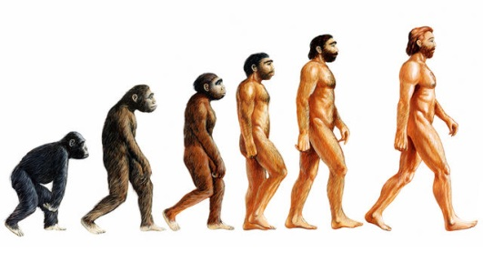 | The girls will be introduced to the idea that characteristics are passed from parents to their offspring, for instance by considering different breeds of dogs, and what happens when, for example, Labradors are crossed with Poodles. They will also look at genetics and inheritance in their own families. We will discover how variation in offspring over time can make animals more or less able to survive in particular environments; adaptation to survive in extreme environments will link to our studies in History on the Polar Regions. We will consider how adaptation may lead to evolution. We will also explore how fossils can provide information about living things that inhabited the Earth millions of years ago. Our studies will include finding out about the work of palaeontologists such as Mary Anning and about how Charles Darwin and Alfred Wallace developed their ideas on evolution. | Plan enquiries, including recognising and controlling variables where necessary.  Use appropriate techniques, apparatus, and materials during fieldwork and laboratory work.  Take measurements, using a range of scientific equipment, with increasing accuracy and precision.  Record data and results of increasing complexity using scientific diagrams and labels, classification keys, tables, bar and line graphs, and models.  Report findings from enquiries, including oral and written explanations of results, explanations involving causal relationships, and conclusions.  Present findings in written form, displays and other presentations.  Use test results to make predictions to set up further comparative and fair tests.  Use simple models to describe scientific ideas, identifying scientific evidence that has been used to support or refute ideas or arguments.
Animals including Humans  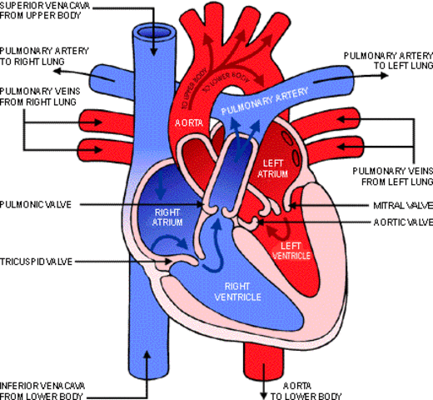 | The girls will share their prior understanding of the human body by locating the major organs on a skeleton. We will explore the functions of the main organs through diagrams, investigations, models and video clips. We will learn to identify and name the main parts of the human circulatory system, and describe the functions of the heart, blood vessels and blood. We will also learn to identify and name the main parts of the human respiratory system, and describe the process. The girls will explore lung capacity through practical experiments. Through research, we will learn about the importance of diet, exercise, drugs and lifestyle on the way the human body functions; the girls will create leaflets to teach others what they have found out.
Light & Electricity  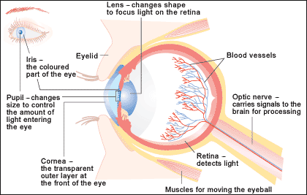  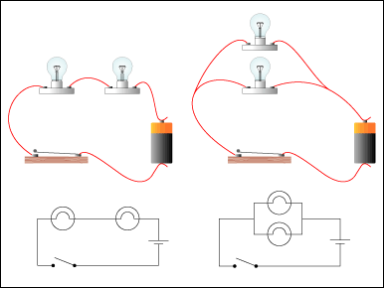 | The girls will investigate the idea that light travels in straight lines, along with reflected and refracted light, through practical experiments. They will be able to use the idea that light travels in straight lines to explain why shadows have the same shape as the objects that cast them, and to predict the size of shadows when the position of the light source changes – shadow investigations will be carried out in small groups. We will move on to a study of the human eye, using video material and diagrams to support understanding. The girls will learn that we see things because light travels from light sources to our eyes, or from light sources to objects and then to our eyes. We will also explore the fact that white light is made of many colours.  The girls will explore and learn to build electrical circuits. They will be able to associate the brightness of a lamp, or the volume of a buzzer, with the number and voltage of cells used in the circuit. They will compare and give reasons for variations in how components function, including the brightness of bulbs, the loudness of buzzers and the on/off position of switches. The girls will be taught how to recognise and use symbols when representing a simple circuit in a diagram. The topic will culminate with a Design and Technology project where the girls will make their own electrical circuit games.
Living Things & their Habitats  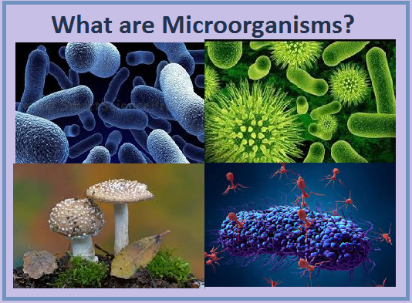 | Building on their learning, the girls will look at the classification system in more detail. They will be introduced to the idea that broad groupings, such as micro-organisms, plants and animals can be subdivided. Through direct observations where possible, they will classify animals into commonly found invertebrates and vertebrates and will discuss reasons why living things are placed in one group and not another. As part of the work on micro-organisms, they will explore Scientific research into Germ Theory, by looking at the work of Louis Pasteur and Edward Jenner and understand the main characteristics of different microbes.

Year 6 - History
Topic / Area of study | Description | The skills the girls will develop through these topics
Suffragettes and Parliament  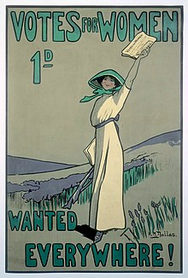 | The girls will learn about social and political change for women from 1903 to 1979 (social reform and the Suffragettes). We will consider the broader social and political development of votes for women from the early suffrage movement to the first woman taking her seat in Parliament in 1919. We will look at Government, Parliament, and Laws today – recognising that there are different forms of government, the importance that rules and laws play, along with the role of Parliament, local MPs, and different political parties. Throughout our studies, we will use a range of historical sources – images, animations and videos, articles, and web links. | To investigate and interpret the past by using sources of evidence to deduce information. To understanding that no single source of evidence gives the full answer to questions about the past  To communicate historically by using appropriate historical vocabulary to communicate and by using literacy and computing skills to communicate information about the past  To understand chronology by describing the main changes in a period of history  To share their knowledge and understanding of past events by describing and making links between events, and changes across periods. As they communicate, they will use dates and historical vocabulary to describe the period  To use historical enquiry skills as they use (and question) a variety of sources to find out about events, people and changes
WW2 | The girls will explore the events that led up to the outbreak of World War Two. We will look at how the war changed the course of history, and the effect it had on Britons lives. The girls will compare this period with life today, looking at culture, economy, and politics. Using their historical enquiry skills, the girls will investigate the history of World War 2 through a range of historical sources – images, animations and videos, articles, and web links.

Year 6 - Geography
Topic / Area of study | Description | The skills the girls will develop through this topic
Global/ Polar Regions – Arctic and Antarctic  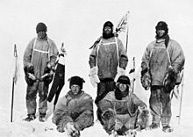 | In this unit the girls will learn about the polar regions – the Arctic and Antarctic. We will explore geographic location, climatic and physical features, along with the water cycle and how it is changing over time. Studies will also include exploration of these regions – considering why the explorers were drawn there, which will allow some cross-curricular work in English as we investigate newspaper reports and diary entries. The girls will imagine themselves as polar explorers and plan their own expedition. The focus will extend to animal adaptation (as linked to Science) and the dangers the animals face, as we consider the human impact and climate change. Will we investigate the settlers living in the polar regions, along with the effects of tourism and exploration. | Identify and describe the geographical significance of latitude, longitude, Equator, Northern Hemisphere, Southern Hemisphere, the Tropics of Cancer and Capricorn, Arctic and Antarctic Circle, and time zones (including day and night).  Investigate places by using a range of geographical resources to give detailed descriptions and opinions of the characteristic features of a location.  Identify and describe how the physical features affect the human activity within a location.  Consider the human geography of the locations, including: settlements, land use, economic activity including trade links, and the distribution of natural resources.
South America  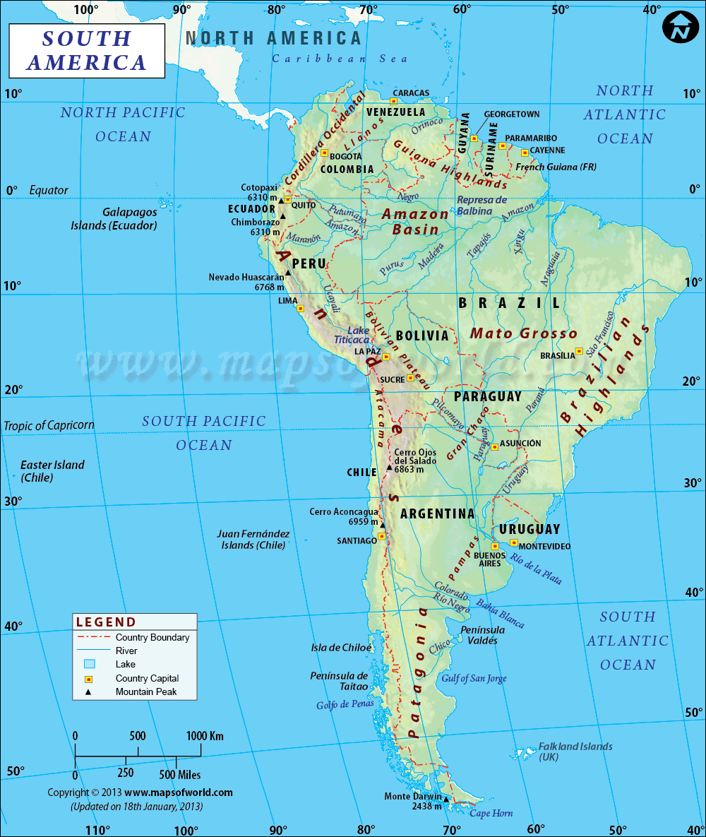 | The girls will extend their knowledge and understanding beyond the UK and Europe, to South America. This will include the location and characteristics of the most significant human and physical features. The girls will develop their use of geographical knowledge and skills to enhance their locational and place knowledge. They will develop mapwork skills, concentrating on environmental regions, key physical and human characteristics, countries, and major cities. The girls will produce projects on specific countries and events which they will present to their peers. | Name and locate some of the countries and cities of the world and their identifying human and physical characteristics, including hills, mountains, rivers, key topographical features and land-use patterns; and understand how some of these aspects have changed over time.  Name and locate the countries of North and South America and identify their main physical and human characteristics.  Create maps of locations identifying patterns (such as: land use, climate zones, population densities, height of land).
Field Study  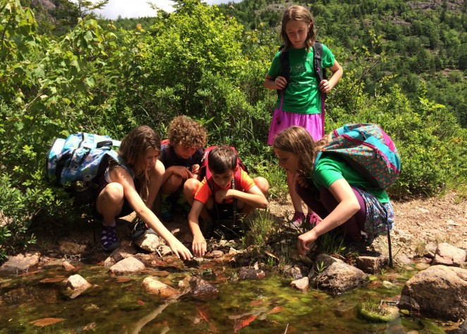 | In the middle of the summer term we pack our cases and head off on a Residential Trip. We will take the opportunity to explore the area, looking at tourism and how this relates to land use. We will also look at local processes in action. | Identify and describe how the physical features affect the human activity within a location.  Use a range of geographical resources to give descriptions and opinions of the characteristic features of a location.  Use different types of fieldwork sampling to observe, measure and record the human and physical features in the local area. To record the results in a range of ways.  To use the eight points of a compass, four-figure grid references, symbols and a key (that uses standard Ordnance Survey symbols).
Year 6 – Additional Subjects
RE
Topics to be covered:
- Christianity – The Last Week of Jesus Life
- Humanism – Living as a Humanist
- Buddhism – Living as a Buddhist

PSHEE/Philosophy
Topics to be covered:
- Keeping/ Staying Safe
- Keeping/Staying Healthy, Growing and Changing
- Being Responsible
- Feelings and Emotions
- Computer Safety
- The Working World
- A World without Judgement
- First Aid

Computer Science
Topics to be covered:
- eSafety
- Coding: More Complex Variables
- Extended Digital Skills
- Coding HTML
- Collaborative digital multi-skills project

Languages
The focus within French will be speaking and listening, which will be applied in a range of conversational and role-play situations. Other strands which will enrich this are reading and writing. The girls will also develop an awareness of the cultural aspects within French speaking provinces. Topics which will be studied include physical descriptions, French Alphabet, School descriptions and places, restaurants, and food.
Design and Technology
The girls will use fabric dyes to create quilted/embroidered pictures (using a range of stitches and decorations). Their creativity will be encouraged in their selection of colour and design. The girls will complete a STEM Lego project applying problem solving, critical thinking and spatial reasoning through hands-on building and design. They will work as a team to experiment with various solutions developing logical thinking. They will then make and evaluate their product.
Art and Design
The girls will be encouraged to produce creative work, exploring their own ideas. Their work will cover drawing, painting, textiles, and sculpture. The girls will explore people in action using a range of sketching materials – including charcoal and graphite pencils. They will also explore textiles, including weaving and tie-dye. At all stages, the girls will be taught to develop their techniques, including their control. They will learn about great artists, architects, and designers.
Music
- The girls will continue to develop performance skills and build on their musical knowledge
- To sing and/or play with confidence and with expression
- To understand the use of the sharp and the flat symbols
- To develop their understanding of musical notation and a widening vocabulary in order to appraise music
- To develop their composition skills
PE
- Uphold the spirit of fair play and respect in all competitive situations
- Play competitive games, modified where appropriate
- To develop gross and fine motor skills in the relevant activity
- To use and apply these skills with growing accuracy and consistency within competitive situations
- To demonstrate a good kinaesthetic awareness, holding shapes and moving with fluency and expression
- Swim fluently with controlled strokes
- Sports to include netball, hockey, athletics, cricket, gymnastics, dance and fitness.
Forest School
Your daughter will have opportunities to develop her skills and knowledge in the following areas: Tool use, Ropes and Knots, Fires, Dens and Shelters, Tree climbing and Flora and Fauna. Personal, Social and Emotional Development is a constant feature throughout all of the sessions as the girls experience supported risk taking, physical challenges, working as part of a group, problem solving, choice, opportunities for reflection, solitude and discussion of feelings and emotions to promote self-awareness, social awareness and positive mental health.
- Use a knife to whittle green wood
- Select tools suitable for a task
- Select wood suitable for a task
- Choose an appropriate knot to tie up a hammock
- Use knowledge of knots to put up a zip-wire
- Choose and use appropriate knots for the task (den-building, rope swing, rope walk
- Light a fire independently in different ways
- Keep the fire alight and fed with fuel
- Plan, prepare and cook a meal on an open fire
- Adapt and improve shelter building techniques
- Use knots learnt to tie parts of shelter
- Attempt to build a shelter off the ground
- Challenge themselves with more difficult climbing challenges
- Talk about the checks and risk assessments they have carried out before starting a task.
- Identify hawthorn, elder, oak, lime, hazel, willow, holly and ivy
- Identify Lords and Ladies
- Notice how different types of flora provide habitats for different animals and birds
- Carry out a Bio-Blitz of FS area (list of living things)
- Have opportunities to talk about how they are feeling
- Experience different relaxation and mindfulness techniques
- Recognise and celebrate their successes
- Work together as part of a group
- Take time to enjoy solitude and the natural environment
- Undertake opportunities to improve or look after the Forest School area

French | Translation (English) | French | Translation (English) | French | Translation (English) | French | Translation (English)
Un pantalon  Un chapeau  Un t-shirt  Une jupe  Une veste  Une robe  Une chemise  Des baskets  Des chaussures  Des chaussettes  Des lunettes (de soleil)  Une casquette  Un collant  Un pull  Un sweat  Je voudrais …  Je m’appelle ..  J’habite à …  Mon anniversaire est le …  J’aime  Je n’aime pas  J’ai les yeux …  J’ai les cheveux ….. et ……  Je suis –  Grand(e)  Petit(e)  Bavarde  Timide  Rigolo  sympa | Trousers  Hat  T-shirt  Skirt  Jacket  Dress  Blouse  Trousers  Shoes  Socks  (sun)glasses  A cap  Tights  Jumper  Sweatshirt  I would like …  I am called …  I live in …  My birthday is on …  I like  I don’t like  My eyes are … (colour)  My hair is …. and …. (colour and length)  I am –  Big  Small  Chatty  Shy  Funny  Kind | L’anglais  Le franҫais  Le sport  L’histoire-géo  Les sciences  Les maths  La musique  L’informatique  La chimie  La biologie  La physique  Le déjeuner  La récréation  Quelle heure est-il?  Il est … heure(s)  Il est midi  Il est minuit  Il est … heure(s) –  Et demie  Et quart  Moins le quart  A quelle heure commence le/la …?  A quelle heure finit le/la …?  La cantine  La bibliothѐque  La classe  La salle de classe  Les toilettes  La maternelle  La cour  Je suis dans le/la .. | English  French  Sport  Geography/history  Science  Maths  Music  IT  Chemistry  Biology  Physics  Lunch(time)  Break  What time is it?  It is … o’clock  It’s midday  It’s midnight  It is ……  Half past  Quarter past  Quarter to  At what time does (subject) start?  At what time does (subject) finish?  Dining room  Library  Class  Classroom  Toilets  Kindergarten  Playground  I am in the … | Tu as des fréres ou des soeurs?  J’ai … | Do you have any borthers or sisters?  I have … | C’est  J’aime les  C’est quelle couleur?  Vert  Rouge  Marron  jaune  bleu  Crѐme  Argent  Or  Violet  Brun  Noir  Gris  Banc  rose  Je voudrais … svp  J’aime…  Je n’aime pas…  Un gâteau  Un sandwich au fromage  Un sandwich au poulet  Un sandwich au thon  Un sandwich aux tomates  Une glace au chocolat  Une glace à l’orange  Une glace à la fraise  Une glace à la vanille  Une pomme  Une poire  Une pêche  Une banane  Une orange  Un citron  Des raisins  Un melon  Un kiwi  Des fraises  Un ananas  Les tomates  Le thon  Le fromage  Une baguette  Le beurre  Les gâteaux  Les fruits  Les bonbons  Les pommes  Les carottes  Les haricots  Mangez  Coupez  Prenez  Mettez  C’est bon pour la santé  Ce n’est pas bon pour la santé | It’s  I like  What colour is it?  Green  Red  Brown  Yellow  Blue  Cream  Silver  Gold  Purple  Brown  Black  Grey  White  Pink  I would like … please  I like …  I don’t like …  Cake  Cheese sandwich  Chicken sandwich  Tuna sandwich  Tomato sandwich  Chocolate ice cream  Orange ice cream  Strawberry ice cream  Vanilla ice cream  Apple  Pear  Peach  Banana  Orange  Lemon  Grapes  Melon  Kiwi  Strawberries  Pineapple  Tomatoes  Tuna  Cheese  Baguette  Butter  Cakes  Fruits  Sweets  Apples  Carrots  Beans  Eat  Cut  Take  Put  It is good for you  It is bad for you

